USER MANUAL FOR BASL MEMBERSHIP

- For access to BASL – Membership Enrolment module, go to the website - https://membership.bseasl.com/

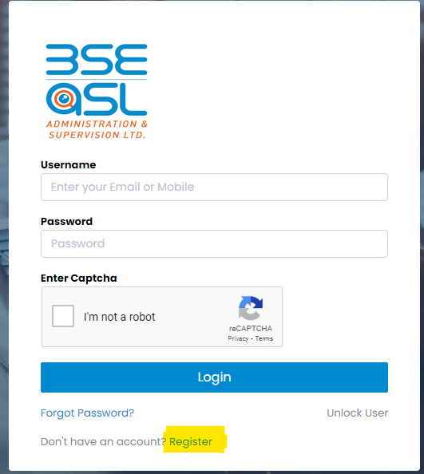

- Applicants need to register themselves by providing their email address and mobile no. details (Click on Register).
- On providing the relevant registration details (as per below screen) OTPs will be generated and sent to the respective email address and mobile nos. which need to be updated for verification.
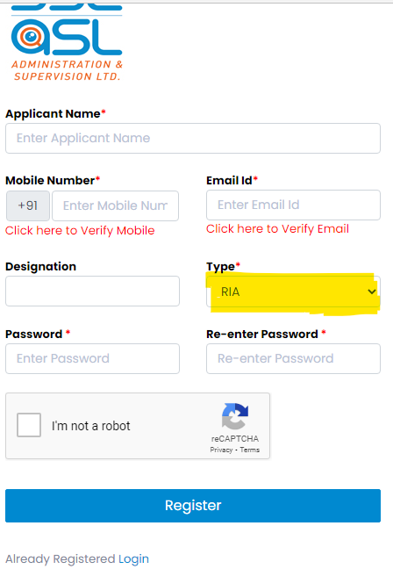

- Select “Type” as per preferred registration
- “RIA” for Investment Adviser
- “Accredited Investor (AI)” for Accredited Investor
- “Investment Provider (IP)” for Investment Provider
- On completion of above login registration process user applicants can re-login by providing their login credentials as per below mentioned screens and access their BASL Membership module.
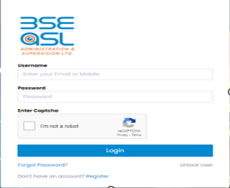
- After re-login to the BASL – Membership module, the below screen will appear for applicant to select their “Application Type” and “Entity Type” options and click “Continue”.
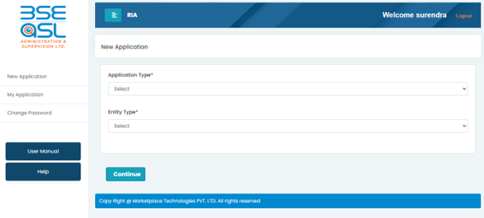

Application Type – New / Existing / Renewal (defined as below) :
- New - Applicant seeking SEBI IA Registration and BASL membership
- Existing - Applicant currently registered as IA with SEBI and applying for BASL membership
- Renewal – Applicant registered with SEBI & BASL and seeking renewal of BASL membership

Entity Type – Individual / Sole Proprietor / Partnership / LLP / Body Corporate

- Applicant will be guided to the next screen wherein they will have to fill the requisite details in the multiple tabs.
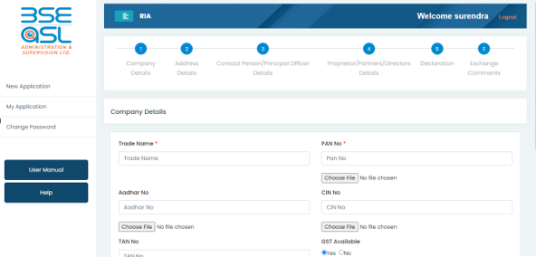
- User can click on sequentially or any of multiple screen tab & upload the relevant documents required for the membership enrolment.
Entity Type | Individual | Sole Proprietor | Partnership/LLP/Corporate Body
Sr. No.
 | Screens for Membership Application
1. | Application Details | Company Details | Company Details
2. | Address Details | Address Details | Address Details
3. | Contact Person/Principal Office Details | Contact Person/Principal Office Details | Contact Person/Principal Office Details
4. | Declaration | Proprietor Details | Partners/Director Details
5. | Exchange Comments | Declaration | Declaration
E |  | Exchange Comments | Exchange Comments

- The user is required to fill all the relevant fields appearing on the screen. The mandatory fields are marked as * and need to be provided failing which the membership enrolment application will not get saved/submitted. The users are also required to provide the supporting document or attachments for the relevant fields failing which the application will not get saved/submitted.
- In case of users not having GST registration, they are mandatorily required to provide the duly signed declaration as per format provided in the portal for download.
- All documents uploaded on the portal need to be self – attested.
- Applicants can save the updations carried out in respective tab by clicking on “Save as Draft” option at each screen.
- After updation of all the relevant details, the user needs to click on the “I Agree” button on the “Declaration” screen. Then click on the “Submit” button to complete their membership enrolment application process.
- Intimation will be to the applicant on their registered mobile and email address, confirming the successful upload of the BASL – Membership Application.
- Case ID generated by system will appear on the website link and the same can be viewed under “My Application”. Applicant can do changes if any prior to submission of the application. Post submission, if any query raised by BASL then the same can be viewed and edited by applicant by selecting the case id from “My Application” appearing on the left side of the screen.
- “BASL Application No.” get generated by system and the same continues till the login user ID completes with the membership enrolment process.
- The Applicant can change his login password by clicking on to the “Change Password” option appearing on the left side of the screen.
- Applicants may note that “Case Id” as referred in the “My Application” is the “BASL Application No.”
- BASL will process the application submitted by the member and in case of any observation will highlight the same vide message in the “Exchange Comments” screen.
- Applicant will be required to carry-out the relevant rectifications highlighted in the “Exchange Comments” and re-submit the application. On re-submission the application will resend a message in context of same to the registered mobile and email address.
- User can use the “Forgot Password” option and follow process on portal to have the new password.

